**Expt No 1**

**ER diagram and Relational Schema**

**AIM:Design a database schema for an application with ER diagram from a problem description**

**Problem Description:**

The COMPANY database keeps track of a company’s employees, departments, and projects. Suppose that after the requirements collection and analysis phase, the database designers provide the following description of the miniworld—the part of the company that will be represented in the database.

* The company is organized into departments. Each department has a unique name, a unique number, and a particular employee who manages the department. We keep track of the start date when that employee began managing the department. A department may have several locations.
* A department controls a number of projects, each of which has a unique name, a unique number, and a single location.
* We store each employee’s name, Social Security number,address, salary, sex (gender), and birth date. An employee is assigned to one department, but may work on several projects, which are not necessarily controlled by the same department. We keep track of the current number of hours per week that an employee works on each project. We also keep track of the direct supervisor of each employee (who is another employee).
* We want to keep track of the dependents of each employee for insurance purposes. We keep each dependent’s first name, sex, birth date, and relationship to the employee.

**ER Diagram:**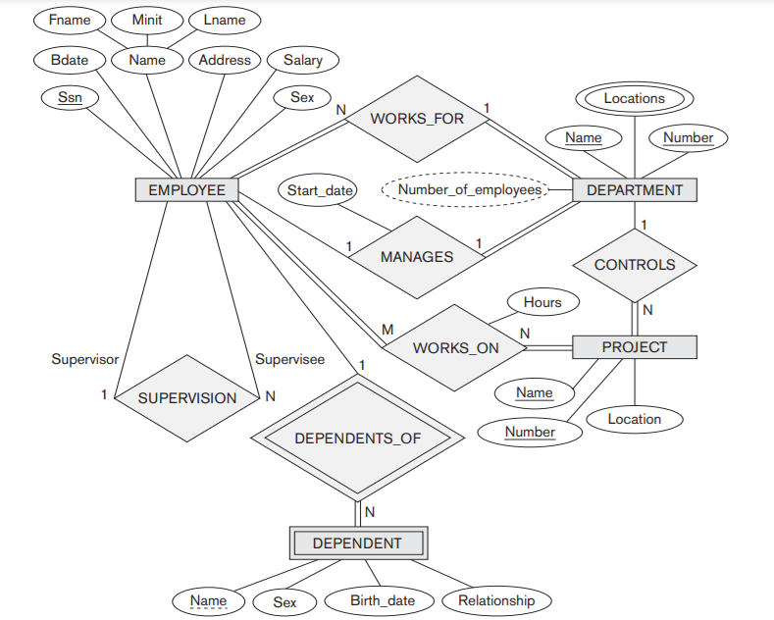

**Entities:**

* An entity type DEPARTMENT with attributes Name, Number, Locations, Manager, and Manager_start_date. Locations is the only multivalued attribute. We can specify that both Name and Number are (separate) key attributes because each was specified to be unique.
* An entity type PROJECT with attributes Name, Number, Location, and Controlling_department. Both Name and Number are (separate) key attributes.
* An entity type EMPLOYEE with attributes Name, Ssn, Sex, Address, Salary, Birth_date, Department, and Supervisor. Both Name and Address may be composite attributes; however, this was not specified in the requirements.
* An entity type DEPENDENT with attributes Employee, Dependent_name, Sex, Birth_date, and Relationship (to the employee).

**Relationship types:**

* MANAGES, a 1:1 relationship type between EMPLOYEE and DEPARTMENT. EMPLOYEE participation is partial. DEPARTMENT participation is not clear from the requirements. We assume that a department must have a manager at all times, which implies total participation.The attribute Start_date is assigned to this relationship type.
* WORKS_FOR, a 1:N relationship type between DEPARTMENT and EMPLOYEE. Both participations are total.
* CONTROLS, a 1:N relationship type between DEPARTMENT and PROJECT. The participation of PROJECT is total, whereas that of DEPARTMENT is determined to be partial, assuming that some departments may control no projects.
* SUPERVISION, a 1:N relationship type between EMPLOYEE (in the supervisor role) and EMPLOYEE (in the supervisee role). Both participations are determined to be partial, assuming that not every employee is a supervisor and not every employee has a supervisor.
* WORKS_ON, determined to be an M:N relationship type with attribute Hours, after the users indicate that a project can have several employees working on it. Both participations are determined to be total. DEPENDENTS_OF, a 1:N relationship type between EMPLOYEE and DEPENDENT, which is also the identifying relationship for the weak entity type DEPENDENT. The participation of EMPLOYEE is partial, whereas that of DEPENDENT is total

**Summary :**

Figure above displays the COMPANY ER database schema as an ER diagram. We now review the full ER diagram notation.

* Entity types such as EMPLOYEE, DEPARTMENT, and PROJECT are shown in rectangular boxes. Relationship types such as WORKS_FOR, MANAGES, CONTROLS, and WORKS_ON are shown in diamond-shaped boxes attached to the participating entity types with straight lines.
* Attributes are shown in ovals, and each attribute is attached by a straight line to its entity type or relationship type.
* Component attributes of a composite attribute are attached to the oval representing the composite attribute, as illustrated by the Name attribute of EMPLOYEE.
* Multivalued attributes are shown in double ovals, as illustrated by the Locations attribute of DEPARTMENT.
* Key attributes have their names underlined.
* Derived attributes are shown in dotted ovals, as illustrated by the Number_of_employees attribute of DEPARTMENT.
* Weak entity types are distinguished by being placed in double rectangles and by having their identifying relationship placed in double diamonds, as illustrated by the DEPENDENT entity type and the DEPENDENTS_OF identifying relationship type. The partial key of the weak entity type is underlined with a dotted line.
* The cardinality ratio of each binary relationship type is specified by attaching a 1, M, or N on each participating edge. The cardinality ratio of DEPARTMENT:EMPLOYEE in MANAGES is 1:1, whereas it is 1:N for DEPARTMENT: EMPLOYEE in WORKS_FOR, and M:N for WORKS_ON.
* The participation constraint is specified by a single line for partial participation and by double lines for total participation (existence dependency).
* In Figure we show the role names for the SUPERVISION relationship type because the same EMPLOYEE entity type plays two distinct roles in that relationship. Notice that the cardinality ratio is 1:N from supervisor to supervisee because each employee in the role of supervisee has at most one direct supervisor, whereas an employee in the role of supervisor can supervise zero or more employees

**Relational Schema:**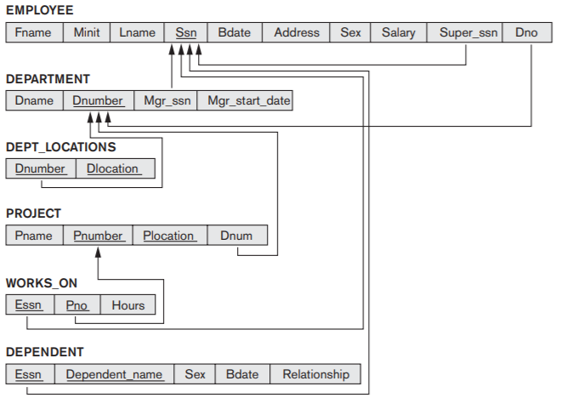

**ER-to-Relational Schema Mapping:**

**Step 1: Mapping of Regular Entity Types**

We create the relations EMPLOYEE, DEPARTMENT, and PROJECT in Figure to correspond to the regular entity types EMPLOYEE, DEPARTMENT, and PROJECT. We choose Ssn, Dnumber, and Pnumber as primary keys for the relations EMPLOYEE, DEPARTMENT, and PROJECT, respectively

**Step 2: Mapping of Weak Entity Types**

We create the relation DEPENDENT in this step to correspond to the weak entity type DEPENDENT. We include the primary key Ssn of the EMPLOYEE relation—which corresponds to the owner entity type—as a foreign key attribute of DEPENDENT; We rename it Essn. The primary key of the DEPENDENT relation is the combination {Essn, Dependent_name}, because Dependent_name is the partial key of DEPENDENT

**Step 3: Mapping of Binary 1:1 Relationship Types.**

We map the 1:1 relationship type MANAGES from Figure by choosing the participating entity type DEPARTMENT to serve in the role of S because its participation in the MANAGES relationship type is total (every department has a manager). We include the primary key of the EMPLOYEE relation as foreign key in the DEPARTMENT relation and rename it Mgr_ssn. We also include the simple attribute Start_date of the MANAGES relationship type in the DEPARTMENT relation and rename it Mgr_start_date

**Step 4: Mapping of Binary 1:N Relationship Types**

We now map the 1:N relationship types WORKS_FOR, CONTROLS, and SUPERVISION from Figure. For WORKS_FOR we include the primary key Dnumber of the DEPARTMENT relation as foreign key in the EMPLOYEE relation and call it Dno. For SUPERVISION we include the primary key of the EMPLOYEE relation as foreign key in the EMPLOYEE relation itself—because the relationship is recursive—and call it Super_ssn. The CONTROLS relationship is mapped to the foreign key attribute Dnum of PROJECT, which references the primary key Dnumber of the DEPARTMENT relation.

**Step 5: Mapping of Binary M:N Relationship Types**

We map the M:N relationship type WORKS_ON from the ER diagram by creating the relation WORKS_ON in relational schema. We include the primary keys of the PROJECT and EMPLOYEE relations as foreign keys in WORKS_ON and rename them Pno and Essn, respectively. We also include an attribute Hours in WORKS_ON to represent the Hours attribute of the relationship type. The primary key of the WORKS_ON relation is the combination of the foreign key attributes {Essn, Pno}.

**Step 6: Mapping of Multivalued Attributes**

We create a relation DEPT_LOCATIONS. The attribute Dlocation represents the multivalued attribute LOCATIONS of DEPARTMENT, while Dnumber—as foreign key—represents the primary key of the DEPARTMENT relation. The primary key of DEPT_LOCATIONS is the combination of {Dnumber, Dlocation}. A separate tuple will exist in DEPT_LOCATIONS for each location that a department has.

**RESULT:**

**We successfully created an ER diagram from the problem description given. We were also able to extract the relational schema from the ER diagram.**

**Expt No 2**

**APPLICATION OF DDL COMMANDS USING UI AND SQL**

**AIM : Creation, modification, configuration, and deletion of databases using UI and SQL Commands**

**QUERY**

**Create database students and execute various commands on it.**

create database students;

use students;

show databases;

+--------------------+

| Database |

+--------------------+

| information_schema |

| employees |

| mysql |

| students |

| test |

+--------------------+

use students;

**Create a table students with the fields student id, name, email and phone number.**

create table Student(stud_id INT AUTO_INCREMENT PRIMARY KEY,stud_fname VARCHAR(20),stud_lname VARCHAR(20),stud_email VARCHAR(20),stud_ph VARCHAR(10));

**Create a table subject to store the list of subjects.**

create table Subject(sub_id INT AUTO_INCREMENT PRIMARY KEY,sub_name VARCHAR(20));

**Create a table marks to store marks of students for various subjects.**

create table Marks(sub_id INT,stud_id INT,marks INT, PRIMARY KEY(sub_id,stud_id));

show tables;

+--------------------+

| Tables_in_students |

+--------------------+

| marks |

| student |

| subject |

+--------------------+

**Display the details of the tables created.**

desc student;

+------------+-------------+------+-----+---------+----------------+

| Field | Type | Null | Key | Default | Extra |

+------------+-------------+------+-----+---------+----------------+

| stud_id | int(11) | NO | PRI | NULL | auto_increment |

| stud_fname | varchar(20) | YES | | NULL | |

| stud_lname | varchar(20) | YES | | NULL | |

| stud_email | varchar(20) | YES | | NULL | |

| stud_ph | varchar(10) | YES | | NULL | |

+------------+-------------+------+-----+---------+----------------+

desc subject;

+----------+-------------+------+-----+---------+----------------+

| Field | Type | Null | Key | Default | Extra |

+----------+-------------+------+-----+---------+----------------+

| sub_id | int(11) | NO | PRI | NULL | auto_increment |

| sub_name | varchar(20) | YES | | NULL | |

+----------+-------------+------+-----+---------+----------------+

desc marks;

+---------+---------+------+-----+---------+-------+

| Field | Type | Null | Key | Default | Extra |

+---------+---------+------+-----+---------+-------+

| sub_id | int(11) | NO | PRI | 0 | |

| stud_id | int(11) | NO | PRI | 0 | |

| marks | int(11) | YES | | NULL | |

+---------+---------+------+-----+---------+-------+

**Alter the tables to include foreign keys.**

alter table marks ADD FOREIGN KEY (stud_id) REFERENCES student(stud_id);

alter table marks ADD FOREIGN KEY (sub_id) REFERENCES subject(sub_id);

**Drop the tables created.**

drop table student;

drop table subject;

drop table marks;

drop database students;

alter table student AUTO_INCREMENT=100;

alter table subject AUTO_INCREMENT=200;

**RESULT:** Successfully executed the queries using MySQL Workbench.

**Expt No 3**

**CREATION OF DATABASE SCHEMA AND EXTRACTION OF ER DIAGRAM**

**AIM:** Creation of database schema - DDL (create tables, set constraints, enforce relationships, create indices, delete and modify tables). Export ER diagram from the database and verify relationships (with the ER diagram designed in step 1).

Create a database schema for the below diagram.



**QUERY:**

**EER diagram: <SCREENSHOT>**

**RESULT:**

**We successfully created the Database Schema from the problem description given. We were also able to export the ER diagram from the database and relationships are verified.**

**Expt No 4**

**APPLICATION OF DML COMMANDS USING SQL**

**AIM :Insertion, updation, deletion, and selection of databases using SQL Commands**

**Insert data into the students table.**

insert into student(stud_fname,stud_lname,stud_email,stud_ph) values('shanti','vasan','shantiv@gmail.com',9677483824);

mysql> insert into student(stud_fname,stud_lname,stud_email,stud_ph) values('anjitha','k','anjithak@gmail.com',9574884993);

mysql> insert into student(stud_fname,stud_lname,stud_email,stud_ph) values('riya','khan','riyakhan@gmail.com',9637833993);

**Insert data into the subject table.**

insert into subject(sub_name) values('chemistry');

insert into subject(sub_name) values('physics');

insert into subject(sub_name) values('maths');

**Insert data into marks table.**

insert into marks(sub_id,stud_id,marks) values(200,100,75);

insert into marks(sub_id,stud_id,marks) values(200,101,94);

insert into marks(sub_id,stud_id,marks) values(200,102,60);

insert into marks(sub_id,stud_id,marks) values(201,100,85);

insert into marks(sub_id,stud_id,marks) values(201,101,98);

insert into marks(sub_id,stud_id,marks) values(201,102,70);

insert into marks(sub_id,stud_id,marks) values(202,100,50);

insert into marks(sub_id,stud_id,marks) values(202,101,96);

insert into marks(sub_id,stud_id,marks) values(202,102,45);

**Update the lname to ‘rajan’ of the student having student id 100.**

update student set stud_lname='rajan' where stud_id=100;

**Update the subject name to ‘mathematics’ where subject id is 202.**

update subject set sub_name='mathematics' where sub_id=202;

**Update the marks of subject 200 and the student having student id 102 to 83.**

update marks set marks=83 where sub_id=200 AND stud_id=102;

delete from student where stud_id=102;

**SELECT QUERIES:**

select * from student;

+---------+------------+------------+--------------------+------------+

| stud_id | stud_fname | stud_lname | stud_email | stud_ph |

+---------+------------+------------+--------------------+------------+

| 100 | shanti | rajan | shantiv@gmail.com | 9677483824 |

| 101 | anjitha | k | anjithak@gmail.com | 9574884993 |

| 102 | riya | khan | riyakhan@gmail.com | 9637833993 |

+---------+------------+------------+--------------------+------------+

select * from subject;

+--------+-------------+

| sub_id | sub_name |

+--------+-------------+

| 200 | chemistry |

| 201 | physics |

| 202 | mathematics |

+--------+-------------+

select * from marks;

+--------+---------+-------+

| sub_id | stud_id | marks |

+--------+---------+-------+

| 200 | 100 | 75 |

| 200 | 101 | 94 |

| 200 | 102 | 83 |

| 201 | 100 | 85 |

| 201 | 101 | 98 |

| 201 | 102 | 70 |

| 202 | 100 | 50 |

| 202 | 101 | 96 |

| 202 | 102 | 45 |

+--------+---------+-------+

**1.Write a query to get the details of a student whoseSTUD_ID is102.**

select *from student where stud_id=102;

+---------+------------+------------+--------------------+------------+

| stud_id | stud_fname | stud_lname | stud_email | stud_ph |

+---------+------------+------------+--------------------+------------+

| 102 | riya | khan | riyakhan@gmail.com | 9637833993 |

+---------+------------+------------+--------------------+------------+

**2.Write a query to display student name, subject and marks of student ordered by marks.**

select stud_fname,sub_name,marks from student,subject,marks where student

.stud_id=marks.stud_id and subject.sub_id=marks.sub_id order by marks;

+------------+-------------+-------+

| stud_fname | sub_name | marks |

+------------+-------------+-------+

| riya | mathematics | 45 |

| shanti | mathematics | 50 |

| riya | physics | 70 |

| shanti | chemistry | 75 |

| riya | chemistry | 83 |

| shanti | physics | 85 |

| anjitha | chemistry | 94 |

| anjitha | mathematics | 96 |

| anjitha | physics | 98 |

+------------+-------------+-------+

**3.Write a query to display student name, subject and marks of students who have marks greater than 70 in physics.**

select stud_fname,sub_name,marks from student,subject,marks where student

.stud_id=marks.stud_id and subject.sub_id=marks.sub_id and marks>70 and sub_name

='physics';

+------------+----------+-------+

| stud_fname | sub_name | marks |

+------------+----------+-------+

| shanti | physics | 85 |

| anjitha | physics | 98 |

+------------+----------+-------+

**4.Write a query to display average marks in each subject.**

select sub_name,avg(marks)from student,subject,marks where student.stud_i

d=marks.stud_id and subject.sub_id=marks.sub_id group by sub_name;

+-------------+------------+

| sub_name | avg(marks) |

+-------------+------------+

| chemistry | 84.0000 |

| mathematics | 63.6667 |

| physics | 84.3333 |

+-------------+------------+

**5.Write a query to display the number of students.**

select count(stud_id) from student;

+----------------+

| count(stud_id) |

+----------------+

| 3 |

+----------------+

**6.Write a query to display the maximum and minimum marks obtained by students in each subject.**

select sub_name,max(marks),min(marks) from student,subject,marks where student.stud_id=marks.stud_id and subject.sub_id=marks.sub_id group by sub_name;

+-------------+------------+------------+

| sub_name | max(marks) | min(marks) |

+-------------+------------+------------+

| chemistry | 94 | 75 |

| mathematics | 96 | 45 |

| physics | 98 | 70 |

+-------------+------------+------------+

**7.Write a query to display the details of a student whose name begins with S.**

select * from student where stud_fname like 's%';

+---------+------------+------------+-------------------+------------+

| stud_id | stud_fname | stud_lname | stud_email | stud_ph |

+---------+------------+------------+-------------------+------------+

| 100 | shanti | rajan | shantiv@gmail.com | 9677483824 |

+---------+------------+------------+-------------------+------------+

**8.Write a query to display the details of a student whose first name contains a in the fourth place.**

select * from student where stud_fname like '___a';

+---------+------------+------------+--------------------+------------+

| stud_id | stud_fname | stud_lname | stud_email | stud_ph |

+---------+------------+------------+--------------------+------------+

| 102 | riya | khan | riyakhan@gmail.com | 9637833993 |

+---------+------------+------------+--------------------+------------+

**9.Write a query to display the name,subject and marks of students having marks between 50 and 75.**

select stud_fname,sub_name,marks from student,subject,marks where student.stud_id=marks.stud_id and subject.sub_id=marks.sub_id and marks between 50 and75;

+------------+-------------+-------+

| stud_fname | sub_name | marks |

+------------+-------------+-------+

| shanti | chemistry | 75 |

| riya | physics | 70 |

| shanti | mathematics | 50 |

+------------+-------------+-------+

**10. Create a view to display student name and marks**

CREATE VIEW stud1 AS SELECT stud_fname,stud_lname,sub_name,marks from stu

dent,subject,marks where student.stud_id=marks.stud_id and subject.sub_id=marks.

sub_id;

select * from stud1;

+------------+------------+-------------+-------+

| stud_fname | stud_lname | sub_name | marks |

+------------+------------+-------------+-------+

| shanti | rajan | chemistry | 75 |

| anjitha | k | chemistry | 94 |

| riya | khan | chemistry | 83 |

| shanti | rajan | physics | 85 |

| anjitha | k | physics | 98 |

| riya | khan | physics | 70 |

| shanti | rajan | mathematics | 50 |

| anjitha | k | mathematics | 96 |

| riya | khan | mathematics | 45 |

+------------+------------+-------------+-------+

**RESULT:** Successfully executed the queries using SQL DML Commands.

**Expt No 5**

**IMPLEMENTATION OF BUILT IN FUNCTIONS**

**AIM**: Implementation of built in functions in RDBMS

1. Create a table store. Fields are order no, code, item, quantity, price, discount, mrp

**QUERY**

Create table store (order_no int primary key, code int, item char(15), quantity varchar(8), price int,

discount varchar(7), mrp int);

Insert into store values(‘1’, ‘1’, ‘soap’, ‘5’, ‘75’, ‘2%’, ‘72’,);

1 row created;

Insert into store values(‘2’, ‘2’, ‘chilly powder’, ‘2’, ‘24’, ‘3%’, ‘20’,);

1 row created;

Insert into store values(‘3’, ‘3’, ‘atta’, ‘2’, ‘70’, ‘3%’, ‘78’,);

1 row created;

Insert into store values(‘4’, ‘4’, ‘pepper’, ‘5’, ‘524’, ‘5%’, ‘520’,);

1 row created;

Insert into store values(‘5’, ‘5’, ‘salt’, ‘4’, ‘40’, ‘2%’, ‘39’,);

1 row created;

1. Display the table;

**QUERY**

Select * from store;

**OUTPUT**

Oder_no code item quantity price discount mrp

1 1 soap 5 75 2% 72

2 2 chilly powder 2 24 3% 20

3 3 atta 2 70 3% 78

4 4 pepper 5 524 5% 520

5 5 salt 4 40 2% 39

c. Write an SQL query to display the reminder, if the amount of an each item in store is

divided by 9.

**QUERY**

Select item, mod(mrp,9) from store;

**OUTPUT**

Item mod(mrp)

Soap 0

chilly powder 2

atta 6

pepper 7

salt 3

d. Write SQL query to display the amount in store and its square.

**QUERY**

Select price, power(price,2) as power from store;

**OUTPUT**

Price Power

75 5625

24 576

70 49000

524 274576

40 1600

e. Program to divide the amount in stock of each item by 7 in store table and display the resut

round to the nearest integer.

**QUERY**

Select price, round(price/7,0) as round from store;

**OUTPUT**

Price Round

75 11

24 3

70 10

524 75

40 6

**RESULT:** Successfully executed the queries using SQL DML Commands.

**EXPT NO:-6**

**AGGREGATE FUNCTIONS**

**AIM:-Implementation of various aggregate functions in SQL**

1)**Find the sum of the salaries of all employees, the maximum salary,the minimum salary, and the average salary.**

SELECT SUM (Salary), MAX (Salary), MIN (Salary), AVG (Salary)

FROM EMPLOYEE;

2)**Find the sum of the salaries of all employees of the ‘Research’department, as well as the maximum salary, the minimum salary, and the average salary in this department.**

SELECT SUM (Salary), MAX (Salary), MIN (Salary), AVG (Salary)

FROM (EMPLOYEE JOIN DEPARTMENT ON Dno=Dnumber)

WHERE Dname=‘Research’;

3)**Retrieve the total number of employees in the company and the number of employees in the ‘Research’ department**

SELECT COUNT (*)FROM EMPLOYEE;

SELECT COUNT (*)FROM EMPLOYEE, DEPARTMENT WHERE DNO=DNUMBER AND DNAME=‘Research’;

4)**Count the number of distinct salary values in the database.**

SELECT COUNT (DISTINCT Salary) FROM EMPLOYEE;

**RESULT:** Successfully executed the queries using SQL DML Commands.

**EXPT NO:-7**

**ORDER BY,GROUP BY AND HAVING CLAUSE**

**AIM:-Implementation of order by,group by and having clause**

1)**For each department, retrieve the department number, the number of employees in the department, and their average salary.**

SELECT Dno, COUNT (*), AVG (Salary) FROM EMPLOYEE GROUP BY Dno;

2)**For each project, retrieve the project number, the project name, and the number of employees who work on that project.**

SELECT Pnumber, Pname, COUNT (*)

FROM PROJECT, WORKS_ON

WHERE Pnumber=Pno

GROUP BY Pnumber, Pname;

3)**For each project on which more than two employees work, retrieve the project number, the project name, and the number of employees who work on the project.**

SELECT Pnumber, Pname, COUNT (*)

FROM PROJECT, WORKS_ON

WHERE Pnumber=Pno

GROUP BY Pnumber, Pname

HAVING COUNT (*) > 2;

4)**For each project, retrieve the project number, the project name, and the number of employees from department 5 who work on the project.**

SELECT Pnumber, Pname, COUNT (*)

FROM PROJECT, WORKS_ON, EMPLOYEE

WHERE Pnumber=Pno AND Ssn=Essn AND Dno=5

GROUP BY Pnumber, Pname;

5)**For each department that has more than five employees, retrieve the department number and the number of its employees who are making more than $40,000.**

SELECT Dnumber, COUNT (*)

FROM DEPARTMENT, EMPLOYEE

WHERE Dnumber=Dno AND Salary>40000 AND

( SELECT Dno

FROM EMPLOYEE

GROUP BY Dno

HAVING COUNT (*) > 5)

**RESULT:** Successfully executed the queries using SQL DML Commands.

**ExpNo:8**

**NESTED QUERIES , JOIN QUERIES AND SET OPERATORS**

**AIM**: To perform nested Queries , joining Queries and set operations using DML command

**QUERIES**

**1. Display all employee names and salary whose salary is greater than minimum salary of the company**

SQL>select Fname,Lname,Salary from Employee where Salary>(select min(Salary) from Employee);

**2. Issue a query to display information about employees who earn more than any employee in dept no 5**

SQL> select * from Employee where Salary>(select max(Salary) from Employee where Dno=5);

**3. Display the details of those who draw the salary greater than the average salary.**

SQL> select distinct * from Employee x where x.Salary >= (select avg(Salary) from Employee);

**4. Write SQL Query which retrieves the name and address of every employee who works for the Research Department**

Select Fname,Lname,Address from(Employee JOIN DEPARTMENT ON Dno=Dnumber) where Dname=’Research’

**5 Retrieve the name of each employee who has a dependent with the same first name and is the same sex as the employee.**

SQL>Select E.Fname, E.Lname From Employee as E where E.Ssn in ( Select Essn From Dependent as D where E.Fname=D.Dependent_Name and E.Sex=D.Sex );

**6. Make a list of all project numbers for projects that involve an employee whose last name is ‘Smith’, either as a worker or as a manager of the department that controls the project.**

SQL> (Select distinct Pnumber from Project, Department, Employee where Dnum=Dnumber and Mgr_Ssn=Ssn And Lname=‘Smith’ ) union ( Select Distinct Pnumber From Project, Works_On, Employee Where Pnumber=Pno and Essn=Ssn And Lname=‘Smith’ );

**7. Write a query to display the name for all employees who work in a department with any employee whose Fname contains h**

Select Fname from Employee where Dno IN (Select Dno from Employee where Fname LIKE ‘%h%’);

**8. Write a SQL query to find those employees who work in the same department where 'Ramesh' works. Exclude all those records where first name is 'Ramesh'. Return first name, last name**

SELECT first_name, last_name FROM employees WHERE DNO = ( SELECT DNO FROM employees WHERE first_name = 'Ramesh') AND first_name <> 'Ramesh';

**9 Display all the dept numbers available in emp and not in dept tables and vice versa.**

SQL> Select Dno from Employee minus select Dnumber from Department; SQL> Select Dnumber from Department minus select Dno from Employee;

**RESULT**

The query was executed and output was successfully obtained.

**Exp No-9**

**TCL COMMANDS**

**AIM**:Implementation of SQL TCL commands Rollback,Commit,Savepoint.

1. Create a table Student having field id,name,mark

**QUERY**

Create table Student(id int primary key,name varchar(20),mark int);

Insert into Student values(1,’Anu’,45);

1 row created;

Insert into Student values(2,’Manu’,43);

1 row created;

Insert into Student values(3,’Veena’,47);

1 row created;

Insert into Student values(4,’Seena’,40);

1 row created;

**B. Display the table;**

**QUERY**

Select * from store;

**OUTPUT**

id name mark

1 Anu 45

2 Manu 43

3 Veena 47

4 Seena 40

**C. Implement Savepoint**

**QUERY**

Update Student mark=49 where id=4;

Savepoint a;

//Display table

Select * from Student ;

id name mark

1 Anu 45

2 Manu 43

3 Veena 47

4 Seena 49

Delete from Student where id=2;

Insert into Student values(2,’Neethu’,42);

Savepoint b;

//Display table

Select * from Student ;

id name mark

1 Anu 45

2 Neethu 42

3 Veena 47

4 Seena 49

**D.Implementation of Rollback**

**QUERY**

Rollback to a;

//Display table

Select * from Student ;

id name mark

1 Anu 45

2 Manu 43

3 Veena 47

4 Seena 49

**E. Implementation of Commit**

//Display table

Select * from Student ;

id name mark

1 Anu 45

2 Manu 43

3 Veena 47

4 Seena 49

**QUERY**

Commit;

Rollback to b;

**OUTPUT**

Savepoint b does not exist

//commit command saves the data permanently to the database.All the savepoints are deleted and cannot rollback the same.

**RESULT**

The query was executed and output was successfully obtained.

**Exp No-10**

**DCL COMMANDS FOR GRANT AND REVOKE**

**AIM:Implementation of DCL commands Grant and Revoke**

**QUERY**

**Create Database**

mysql> create database db;

Query OK, 1 row affected (0.03 sec)

**Use Database**

mysql> use db;

Database changed

**Create table student**

mysql> create table student(student_id INT , name varchar (10), age INT);

Query OK, 0 rows affected (0.24 sec)

**Select Current User**

mysql> select current_user;

+----------------+

| current_user |

+----------------+

| root@localhost |

+----------------+

1 row in set (0.00 sec)

**Granting Permissions to student table**

mysql> grant insert,delete on student to root@localhost;

Query OK, 0 rows affected (0.02 sec)

**View Permissions on the table**

mysql> show grants for root@localhost;

+---------------------------------------------------------------------+

| Grants for root@localhost |

+---------------------------------------------------------------------+

| GRANT ALL PRIVILEGES ON *.* TO 'root'@'localhost' WITH GRANT OPTION |

| GRANT DELETE ON `emp`.`employee` TO 'root'@'localhost' |

| GRANT INSERT, DELETE ON `db`.`student` TO 'root'@'localhost' |

| GRANT PROXY ON ''@'' TO 'root'@'localhost' WITH GRANT OPTION |

+---------------------------------------------------------------------+

4 rows in set (0.00 sec)

**Revoking Permissions**

mysql> revoke insert on student from root@localhost;

Query OK, 0 rows affected (0.00 sec)

mysql> show grants for root@localhost;

+---------------------------------------------------------------------+

| Grants for root@localhost |

+---------------------------------------------------------------------+

| GRANT ALL PRIVILEGES ON *.* TO 'root'@'localhost' WITH GRANT OPTION |

| GRANT DELETE ON `emp`.`employee` TO 'root'@'localhost' |

| GRANT DELETE ON `db`.`student` TO 'root'@'localhost' |

| GRANT PROXY ON ''@'' TO 'root'@'localhost' WITH GRANT OPTION |

+---------------------------------------------------------------------+

4 rows in set (0.00 sec)

**RESULT**

The query was executed and output was successfully obtained.

**Exp No-11**

**Views in SQL**

**AIM:**  Demonstrate View in SQL

1. Create a table store. Fields are order no, code, item, quantity, price, discount, mrp

**QUERY**

Create table store (order_no int primary key, code int, item char(15), quantity varchar(8), price int, discount varchar(7), mrp int);

Insert into store values(‘1’, ‘1’, ‘soap’, ‘5’, ‘75’, ‘2%’, ‘72’,);

1 row created;

Insert into store values(‘2’, ‘2’, ‘chilly powder’, ‘2’, ‘24’, ‘3%’, ‘20’,);

1 row created;

Insert into store values(‘3’, ‘3’, ‘atta’, ‘2’, ‘70’, ‘3%’, ‘78’,);

1 row created;

Insert into store values(‘4’, ‘4’, ‘pepper’, ‘5’, ‘524’, ‘5%’, ‘520’,);

1 row created;

Insert into store values(‘5’, ‘5’, ‘salt’, ‘4’, ‘40’, ‘2%’, ‘39’,);

1 row created;

1. Display the table;

**QUERY**

Select * from store;

**OUTPUT**

Oder_no code item quantity price discount mrp

1 1 soap 5 75 2% 72

2 2 chilly powder 2 24 3% 20

3 3 atta 2 70 3% 78

4 4 pepper 5 524 5% 520

5 5 salt 4 40 2% 39

1. Create a view with item_name and quantity for the above table

**SYNTAX**

Create view name as select field_name1, field name2,...... from table_name;

**QUERY**

Create view v as select item, quantity from store;

View created;

Select * from v;

**OUTPUT**

Item quantity

Soap 5

Chilli powder 2

Atta 2

Pepper 5

Salt 4

1. Write a query to check whether any changes made to present table is reflected in view.

**QUERY**

Update store set quantity=’50kg’ where item=’atta’;

Select * from v;

**OUTPUT**

Item quantity

Soap 5

Chilli powder 2

Atta 50kg

Pepper 5

Salt 4

1. Write a query to delete a view

**QUERY**

Drop view v;

View dropped.

**RESULT**

The query was executed and output was successfully obtained.

**ExpNo:12**

**Implementation of various control structures like IF-THEN,IF-THEN-ELSE,IF-THENELSEIF,CASE ,WHILE USING PL/SQL**

**AIM: To implement various various control structures like IF-THEN,IF-THEN-ELSE,IF-THEN ELSIF,CASE ,WHILE USING PL/SQL**

**a)Write a plsql program to check whether a given number is ODD or EVEN**

**PROGRAM**

| 1  2  3  4  5  6  7  8  9  10  11 | declare  n number:=&n;   begin  if mod(n,2)=0  then  dbms_output.put_line('number is even');  else  dbms_output.put_line('number is odd');  end if;  end;  **/** |
| --- | --- |

**INPUT**

Enter value for n: 6

old 7: n:=&n;

new 7: n:=6;

**OUTPUT**

Number is even

PL/SQL procedure successfully completed.

**b) Write a PL/SQL block to find the maximum number from given three numbers.**

**PROGRAM:**

declare

a number;

b number;

c number;

begin

a:=&a;

b:=&b;

c:=&c;

if (a>b and a>c) then

dbms_output.put_line('a is maximum ' || a);

elsif (b>a and b>c) then

dbms_output.put_line('b is maximum ' || b);

else

dbms_output.put_line('c is maximum ' || c);

end if;

end;

/

**INPUT**

Enter value for a: 6

old 7: a:=&a;

new 7: a:=6;

Enter value for b: 9

old 8: b:=&b;

new 8: b:=6;

Enter value for c: 3

old 9: c:=&c;

new 9: c:=6;

**OUTPUT:**

B is maximum

PL/SQL procedure successfully completed.

**C. Write a program to accept a number and find the sum of the digits**

**PROGRAM**

declare

n number(5):=&n;

s number:=0;

r number(2):=0;

begin

while n !=0

loop

r:=mod(n,10);

s:=s+r;

n:=trunc(n/10);

end loop;

dbms_output.put_line('sum of digits of given number is '||s);

end;

/

**INPUT**

Enter value for n: 146

old 7: n:=&n;

new 7: n:=146;

**OUTPUT**

Sum of digits of given number is 11

PL/SQL procedure successfully completed.

**d)PL/SQL Program to accept a number from user and print number in reverse order.**

**PROGRAM**

declare

num1 number(5);

num2 number(5);

rev number(5);

begin

num1:=&num1;

rev:=0;

while num1>0

loop

num2:=num1 mod 10;

rev:=num2+(rev*10);

num1:=floor(num1/10);

end loop;

dbms_output.put_line('Reverse number is: '||rev);

end;

/

**INPUT**

Enter value for num1: 146

old 7: num1:=&num1;

new 7: num1:=146;

**OUTPUT**

Reverse number is 641

PL/SQL procedure successfully completed.

**e)Program to print the days names in the week.**

**PROGRAM**

declare

d number:=&num1;

begin

case d

when 1 then

dbms_output.put_line('sunday');

when 2 then

dbms_output.put_line('monday');

when 3 then

dbms_output.put_line('tuesday');

when 4 then

dbms_output.put_line('wednesday');

when 5 then

dbms_output.put_line('thursday');

when 6 then

dbms_output.put_line('friday');

when 7 then

dbms_output.put_line('saturday');

else

dbms_output.put_line('invalid day');

end case;

End;

**INPUT**

Enter value for num1: 5

old 7: num1:=&num1;

new 7: num1:=5;

**OUTPUT**

Thursday

PL/SQL procedure successfully completed.

**RESULT**

The plsql program was executed and output was successfully obtained.

**Exp No-13**

**Creation of Procedures, Triggers and Functions**

**AIM**: To implement programs using procedures.

Just as you can in other languages, you can create your own procedures in Oracle. **Syntax**

The syntax to create a procedure in Oracle is:

**CREATE [OR REPLACE] PROCEDURE procedure_name [ (parameter [,parameter]) ]**

**IS**

**[declaration_section]**

**BEGIN**

**executable_section**

**[EXCEPTION**

**exception_section]**

**END [procedure_name];**

There are three types of parameters that can be declared:

1. **IN** - The parameter can be referenced by the procedure or function. The value of the parameter can not be overwritten by the procedure or function.

2. **OUT** - The parameter can not be referenced by the procedure or function, but the value of the parameter can be overwritten by the procedure or function.

3. **IN OUT** - The parameter can be referenced by the procedure or function and the value of the parameter can be overwritten by the procedure or function.

**Drop Procedure**

Once you have created your procedure in Oracle, you might find that you need to remove it from the database.

**Syntax**

The syntax to a drop a procedure in Oracle is:

**DROP PROCEDURE procedure_name;**

procedure_name -The name of the procedure that you wish to drop.

**QUESTION**

1) write a PL/SQL Procedure to find largest of two Numbers

2) create a table emplyee( empid,empname,salary,dept,wef)

write a procedure to accept two arguments empid and salary increment(in %).update the employee table with the salary increment also record the effective date.

**PROGRAM**

1. create procedure largest (a1 in number,b1 in number,c1 out number) as

begin

if (a1>b1) then

c1:=a1;

else

c1:=b1;

end if;

end largest;

set serveroutput on;

declare

a2 number:=&a2;

b2 number:=&b2;

c2 number:=0;

begin

largest(a2,b2,c2);

dbms_output.put_line('Largest: '||c2);

end;

**OUTPUT**

anonymous block completed

Enter the value of a2 : 12

Enter the value of b2 : 25

Largest: 25

2. create table employ(eid number(5),nam varchar(6),sal number(6),dep varchar(8),wef date);

insert into employ values(1,'jose',1000,'finance','03-05-16');

insert into employ values(2,'vimal',2000,'hr','11-06-16'); insert into employ values(3,'yadhu',3000,'sales','17-08-16'); insert into employ values(4,'robin',4000,'finance','09-01-16'); insert into employ values(5,'roshin',5000,'hr','07-04-16');

create procedure upda(a1 in out number,b1 in out number) as

d date;

begin

select sysdate into d from DUAL;

update employ set sal=sal+((sal*b1)/100) where eid=a1; update employ set wef=d where eid=a1;

end upda;

set serveroutput on;

declare

a2 number:=&a2;

a3 number:=&a3;

begin

upda(a2,a3);

end;

**OUTPUT**

select * from employ;

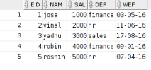

anonymous block completed

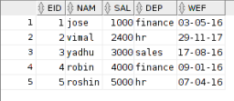

**AIM:To implement programs using triggers**

**TRIGGER**

**QUESTIONS**

1)create a trigger which shows the salary difference of a particular employee whenever salary is getting updated

Worker(id,name,salary)

**PROGRAM**

create table worker(id number(5),name varchar(10),sal number(10));

insert into worker values(1,'riya',25000);

insert into worker values(2,'febi',30000);

insert into worker values(3,'varsha',20000);

insert into worker values(4,'anjali',50000);

insert into worker values(5,'athira',35000);

create trigger t after update of sal on worker for each row

declare

diff number(10);

begin

diff:=:new.sal-:old.sal;

dbms_output.put_line('Difference in salary is '||diff);

end;

set serveroutput on;

declare

n number(3):=&workerid;

nwsal number(5):=&nwsal;

begin

update worker set sal=nwsal where id=n;

end;

**OUTPUT**

select * from worker;

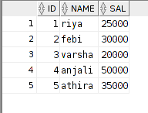

TRIGGER T compiled

anonymous block completed

Enter the worker id =1

Enter the new salary = 28000

anonymous block completed

Difference in salary is 3000

select * from worker;

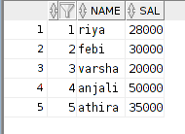

2) create a table theater (movie id, movie name,language,review_ratings).Whenever rating goes below 5 , the movies has to be removed from theater table and add to table outdated movies with attributes movie id and movie name

**PROGRAM**

create table theatre(mov_id number(10),mov_name varchar(20),lang varchar(20),revw number(10));

insert into theatre values(101,'Junglebook','English',6);

insert into theatre values(501,'Parava','Malayalam',8);

insert into theatre values(601,'OSO','Hindi',9);

insert into theatre values(701,'Avengers','English',9);

insert into theatre values(801,'Hobbit','English',7);

insert into theatre values(901,'Don','Hindi',6);

create table outdat(mov_id number(10),mov_name varchar(20));

create trigger trii

after delete on theatre

for each row

begin

insert into outdat values(:old.mov_id,:old.mov_name);

end;

set serveroutput on;

declare

a1 number:=&movie_id;

a2 number:=&new_rating;

begin

if(a2<5) then

delete from theatre where mov_id=a1;

end if;

end;

**OUTPUT**

select * from theatre;

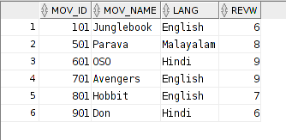

anonymous block completed

Enter the movie_id : 801

Enter the new_rating : 4

select * from theatre;

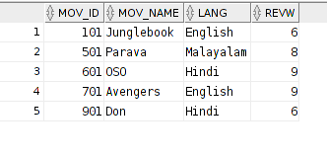

select * from outdat;



**Aim**: To implement programs using functions.

A standalone function is created using the **CREATE FUNCTION** statement. The syntax is given by

CREATE [OR REPLACE] FUNCTION function_name ((parameter_name {IN} type {, ...}))

RETURN return_datatype

{IS | AS}

<declaration section>

BEGIN

< function_body >

END;

Where,

∙ *function-name* specifies the name of the function.

∙ [OR REPLACE] option allows the modification of an existing function.

∙ The optional parameter list contains name, mode and types of the parameters. IN represents the value that will be passed from outside The function must contain a **return** statement.

∙ The *RETURN* clause specifies the data type you are going to return from the function. ∙ *Function-body* contains the executable part.

∙ The AS keyword is used instead of the IS keyword for creating a standalone function.

While creating a function, you give a definition of what the function has to do. To use a function, you will have to call that function to perform the defined task. When a program calls a function, the program control is transferred to the called function.

To call a function, you simply need to pass the required parameters along with the function name and if the function returns a value, then you can store the returned value.

**QUESTIONS**

1)write a PL/SQL function to find factorial of a Number.

2)write a PL/SQL function to find sum of 1st N even Numbers (additional question)

3)sales of different products in one week is recorded

Product (productid,productname,grade)

Sales (prdctname,salesamount,salesday)

Do the following

a) write a function that displays the product name and grade of the given product b)whenever the product sales is grater than the target value it is given a A grade, if there is no sale for a product an exception to be raised

**PROGRAM**

1) create function factorial (a1 in number)

return number

as

f number:=1;

i number:=1;

begin

while(i<=a1)

loop

f:=f*i;

i:=i+1;

end loop;

return (f);

end;

set serveroutput on;

declare

a2 number:=&a2;

c2 number:=0;

begin

c2:=factorial(a2);

dbms_output.put_line('Factorial: '||c2);

end;

**OUTPUT**

anonymous block completed

Enter the value of a2: 6

Factorial: 720

2) create table product(pid number(5),pname varchar(10),pgrade varchar(3));

insert into product values(1,'HDD','a');

insert into product values(2,'GoPro','b');

insert into product values(3,'laptop','b');

insert into product values(4,'mobile','b');

insert into product values(5,'DVD','c');

create table sales(pid number(5),samount number(10),sdate date,sday varchar(15)); insert into sales values(1,1000,'2-10-2017','Monday');

insert into sales values(3,1500,'4-10-2017','Wednesday');

insert into sales values(3,2000,'5-10-2017','Thursday');

insert into sales values(1,3500,'7-10-2017','Saturday');

insert into sales values(3,4000,'3-10-2017','Tuesday');

create function funct(a1 in number,a3 in number)

return number

as

q number;

z number;

r number;

x varchar(10);

y varchar(10);

begin

select pname into x from product where pid=a1;

select pgrade into y from product where pid=a1;

dbms_output.put_line('name of product :'||x);

dbms_output.put_line('grade of product :'||y);

select sum(samount) into q from sales where pid=a1;

dbms_output.put_line('sum of sales of '||a1||' is'||q);

if(q>a3) then

update product set pgrade='a' where pid=a1;

end if;

select count(pid) into z from sales where pid=a1;

if(z<1) then

r:=0;

else

r:=1;

end if;

return(r);

end;

set serveroutput on;

declare

d1 number;

e1 number;

f1 number;

pnull exception;

begin

d1:=&d1;

e1:=&e1;

f1:=funct(d1,e1);

if f1=0 then

raise pnull;

end if;

exception

when pnull then

dbms_output.put_line('no sales corresponding to this pid '); when no_data_found then

dbms_output.put_line('no data found:');

end;

**OUTPUT**

select * from sales;

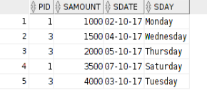select * from product;

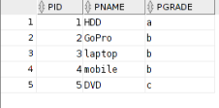

anonymous block completed

Enter the value of d1 : 3

Enter the value of e1 : 5000

name of product :laptop

grade of product :b sum of sales of 3 is 7500 table updated.

select * from product;

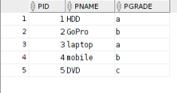anonymous block completed Enter the value of d1 : 2

Enter the value of e1 : 1000 name of product :GoPro grade of product :b sum of sales of 2 is

no sales corresponding to this pid

**Exp No-14**

**Creation of Packages**

A package is a schema object that groups logically related PL/SQL types, variables, and subprograms. Packages usually have two parts, a specification (spec) and a body.

The specification is the interface to the package. It declares the types, variables, constants, exceptions, cursors, and subprograms that can be referenced from outside the package. The body defines the queries for the cursors and the code for the subprograms.

The package body contains the implementation of every cursor and subprogram declared in the package spec. Subprograms defined in a package body are accessible outside the package only if their specs also appear in the package spec. If a subprogram spec is not included in the package spec, that subprogram can only be called by other subprograms in the same package. A package body must be in the same schema as the package spec.

The following is contained in a PL/SQL package

1. Get and Set methods for the package variables

2. Cursor declarations with the text of SQL queries.

3. Declarations for exceptions.

4. Declarations for procedures and functions that call each other.

5. Declarations for overloaded procedures and functions

6. Variables that you want to remain available between procedure calls in the same session **Advantages in using packages**

Modularity

Easier Application Design

Information Hiding

Added Functionality

Better Performance

**Syntax**

CREATE [ OR REPLACE ] PACKAGE [ schema. ] package

[ invoker_rights_clause ]

{ IS | AS } [ item_list_1 ] END [ package_name ] ;

Where

**Schema**- Specify the schema to contain the package. If you omit *schema*, then the database creates the package in your own schema.

**Item list 1** : Declares package elements.

**invoker_rights_clause** : Specifies the AUTHID property of the member functions and procedures of the object type. The AUTHID clause determines whether all the packaged subprograms execute with the privileges of their definer (the default) or invoker, and whether their unqualified references to schema objects are resolved in the schema of the definer or invoker.

CREATE [ OR REPLACE ] PACKAGE BODY

[ schema. ] package

{ IS | AS } [ declare_section ] { body | END package_name } ;

Referencing Package Contents

To reference the types, items, subprograms, and call specs declared within a package spec, use dot notation:

package_name.type_name

package_name.item_name

package_name.subprogram_name

package_name.call_spec_name

**QUESTION**

1) create the table supplier(supplier id,suppliername,commission and city).

create a package comprising of procedure and function .

1. The procedure will accept a supplier id and display the corresponding supplier name,

2. The function will accept the supplier id and calculate the annual commission and finally return the amount

**Algorithm**

1. Create a package with declaration for a procedure and a package.

2. Cretae the package body including the definitions for procedure and function **PROGRAM**

create table supplier(suid number(3),suname varchar(10),sucom number(10),sucity varchar(10));

insert into supplier values(1,'adam',1000,'pune'); insert into supplier values(2,'john',2000,'mumbai'); insert into supplier values(3,'adhya',1500,'kochi'); insert into supplier values(4,'farhaan',3000,'kochi'); insert into supplier values(5,'merina',2500,'banglore');

select * from supplier;

create package pack_age as

procedure alpha(a1 in number,c1 out varchar); function beta(a1 in number) return number; end pack_age;

create package body pack_age as

procedure alpha(a1 in number,c1 out varchar) is

begin

select suname into c1 from supplier where suid=a1; end alpha;

function beta(a1 in number)

return number

is

s1 number:=0;

s2 number;

begin

select sucom into s2 from supplier where suid=a1; s1:=s2*12;

return(s1);

end;

end pack_age;

set serveroutput on;

declare

a1 number:=&a1;

c1 varchar(10);

bb1 number:=0;

begin

pack_age.alpha(a1,c1);

dbms_output.put_line('supplier correspoding to '||a1 ||' is '||c1); end;

set serveroutput on;

declare

b1 number:=&b1;

c1 varchar(10);

bb1 number:=0;

begin

bb1 :=pack_age.beta(b1);

dbms_output.put_line('annual commission for '||b1||' is '||bb1);

end;

**OUTPUT**

create table supplier(suid number(3),suname varchar(10),sucom number(10),sucity varchar(10)); insert into supplier values(1,'adam',1000,'pune');

insert into supplier values(2,'john',2000,'mumbai');

insert into supplier values(3,'adhya',1500,'kochi');

insert into supplier values(4,'farhaan',3000,'kochi');

insert into supplier values(5,'merina',2500,'banglore');

select * from supplier;

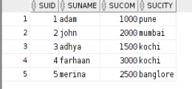

on Executing package and package body(do it as step 1)

PACKAGE PACK_AGE compiled

PACKAGE BODY PACK_AGE compiled

On Executing plsql containing procedure

input: Enter the value of a1 : 3

output: supplier correspoding to 3 is adhya

On Executing plsql containing function

input: Enter the value of b1 : 5 output: annual commission for 5 is 30000

**Exp No-15**

**Creation of Cursors**

**AIM:To implement programs using Cursors**

**QUESTIONS**

1) Consider the table Customer (accout no, customer name,balance amount,date of join).

Implement a PL/SQL block to insert those customers who have current balance greater than 1 Lakh and date of join before 1 january 2010 into the table premium customer who doesnt meet above criteria are to be inserted into table nonpremium customer .

**PROGRAM**

create table customers(acc_no number(16),c_name varchar(15),bal_amt number(10),DOJ date);

create table premium_customers(acc_no number(16),c_name varchar(15),bal_amt number(10),DOF date);

create table nonpremium_customers(acc_no number(16),c_name varchar(15),bal_amt number(10),DOF date);

insert into customers values(101,'anu',150000,'12-12-1998');

insert into customers values(102,'anjana',200000,'19-08-1997');

insert into customers values(208,'achu',50000,'8-09-2003');

insert into customers values(305,'gopika',95000,'10-10-2010');

insert into customers values(409,'irene',25000,'4-03-2011');

insert into customers values(111,'dany',100000,'11-05-2010');

set serveroutput on;

declare

cursor s is select * from customers;

begin

for r in s

loop

if r.bal_amt>100000 and r.doj<'01-01-2010' then

insert into premium_customers values(r.acc_no,r.c_name,r.bal_amt,r.doj);

else

insert into nonpremium_customers values(r.acc_no,r.c_name,r.bal_amt,r.doj);

end if;

end loop;

end;

**OUTPUT**

select * from customers;

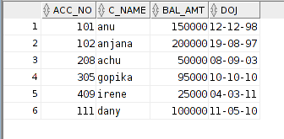

select * from premium_customers;

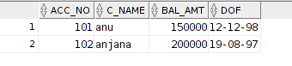

select * from nonpremium_customers;

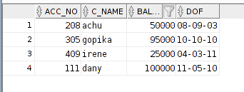

2) Consider the table Account(Customer name,account number,date_last transaction,amount).

Implement a PL/SQL block to perform the following action on the table .

Calculate the interest of each person if it satisfies the condition

a)if the last transaction is not on the current month insert the records into inactive customer

b)otherwise check the balance amount and display the interest amount

i)if the balance amount is less than 50000 interest rate is 5% of the amount

ii)if it is between 250000 and 5 Lakhs interest rate is 10%

iii)if the amount is greater than 5 lakh interest rate is 15%

**PROGRAM**

set serveroutput on;

create table accdetails(accno number(10),cname varchar(20),lastdate date,amount number(7));

insert into accdetails values(101,'anu','08-11-2017',50000);

insert into accdetails values(102,'anagha','10-10-2017',100000);

insert into accdetails values(103,'elizabeth','17-11-2017',25000);

insert into accdetails values(104,'george','06-10-2017',300000);

insert into accdetails values(105,'albyn','15-11-2017',650000);

create table inactive_customer(accno number(10),cname varchar(20));

declare

cursor c1 is select * from accdetails;

a accdetails %rowtype;

n number;

i number;

begin

open c1;

loop

fetch c1 into a.accno,a.cname,a.lastdate,a.amount;

exit when c1 %notfound;

n:=months_between(sysdate,a.lastdate);

if n>=1 then

insert into inactive_customer values(a.accno,a.cname);

else

if a.amount<250000 then

i:=a.amount*0.05;

dbms_output.put_line('interest of '||a.cname|| ' is :'||i);

elsif a.amount>250000 and a.amount<500000 then

i:=a.amount*0.1;

dbms_output.put_line('interest of '||a.cname|| ' is :'||i);

elsif a.amount>500000 then

i:=a.amount*0.15;

dbms_output.put_line('interest of '||a.cname|| ' is :'||i);

else

dbms_output.put_line('error');

end if;

end if;

end loop;

end;

**OUTPUT**

select * from accdetails;

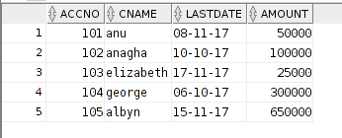

anonymous block completed

interest of anu is :2500

interest of elizabeth is :1250

interest of albyn is :97500

select * from inactive_customer;

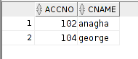

**Exp No:16**

**Creation of plsql blocks for Exception Handling**

AIM:To implement plsql blocks for exception handling

**QUESTION**

Sales of different products in one week is recorded

Product (productid,productname,grade)

Sales (prdctname,salesamount,salesday)

Do the following

a) write a function that displays the product name and grade of the given product b)whenever the product sales is grater than the target value it is given a A grade, if there is no sale for a product an exception to be raised

**Query**

create table product(pid number(5),pname varchar(10),pgrade varchar(3));

insert into product values(1,'HDD','a');

insert into product values(2,'GoPro','b');

insert into product values(3,'laptop','b');

insert into product values(4,'mobile','b');

insert into product values(5,'DVD','c');

create table sales(pid number(5),samount number(10),sdate date,sday varchar(15)); insert into sales values(1,1000,'2-10-2017','Monday');

insert into sales values(3,1500,'4-10-2017','Wednesday');

insert into sales values(3,2000,'5-10-2017','Thursday');

insert into sales values(1,3500,'7-10-2017','Saturday');

insert into sales values(3,4000,'3-10-2017','Tuesday');

create function funct(a1 in number,a3 in number)

 return number

 as

 q number;

 z number;

 r number;

 x varchar(10);

 y varchar(10);

 begin

 select pname into x from product where pid=a1;

 select pgrade into y from product where pid=a1;

 dbms_output.put_line('name of product :'||x);

 dbms_output.put_line('grade of product :'||y);

 select sum(samount) into q from sales where pid=a1;

 dbms_output.put_line('sum of sales of '||a1||' is'||q);

 if(q>a3) then

 update product set pgrade='a' where pid=a1;

 end if;

 select count(pid) into z from sales where pid=a1;

 if(z<1) then

 r:=0;

 else

 r:=1;

 end if;

 return(r);

end;

set serveroutput on;

declare

 d1 number;

 e1 number;

 f1 number;

 pnull exception;

begin

d1:=&d1;

e1:=&e1;

f1:=funct(d1,e1);

if f1=0 then

 raise pnull;

end if;

exception

 when pnull then

 dbms_output.put_line('no sales corresponding to this pid ');  when no_data_found then

 dbms_output.put_line('no data found:');

end;

**OUTPUT**

select * from sales;

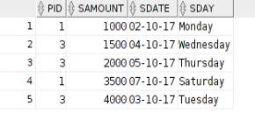select * from product;

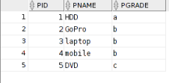

anonymous block completed

Enter the value of d1 : 3

Enter the value of e1 : 5000

name of product :laptop

grade of product :b sum of sales of 3 is 7500 table updated.

select * from product;

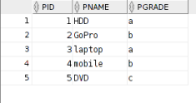anonymous block completed Enter the value of d1 : 2

Enter the value of e1 : 1000 name of product :GoPro grade of product :b sum of sales of 2 is

no sales corresponding to this pid

**Exp No:17**

**Familioarisation of NoSQL Database and CRUD Operations**

**AIM**: Familioarisation of NoSQL Database and CRUD Operations(MONGODB)

**Create the tables mentioned below using crude operation - MongoDB.**

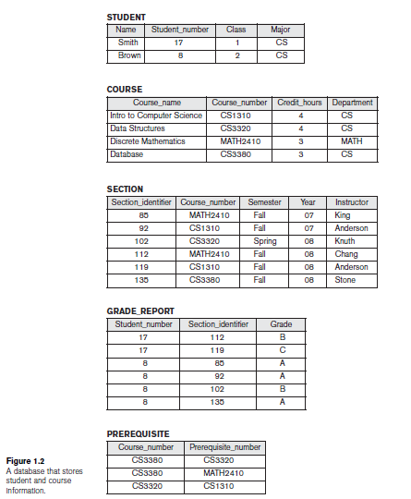

**Starting mongodb:**

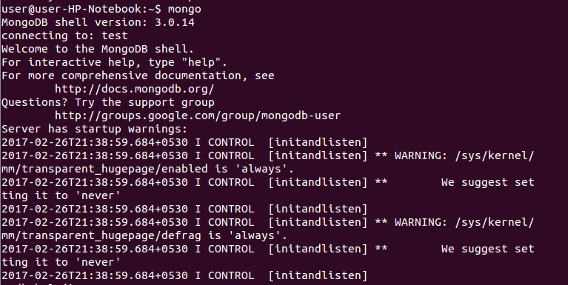

**To create a database “shyama” using “use” command:**

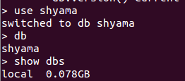

**1.To create a collection “Student” in the database “Shyama”:**

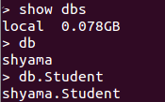

**To insert multiple documents at a time :**

**Step 1) Create a JavaScript variable called myStudent to hold the array of documents**

**Step 2) Add the required documents with the Field Name and values to the variable**

**Step 3) Use the insert command to insert the array of documents into the collection**

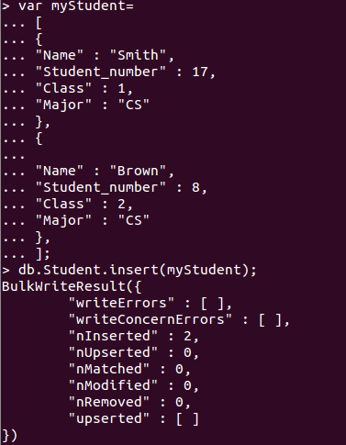

**The output shows that those 3 documents were added to the collection.**

**Use the JSON print functionality to see the output in a better format.**

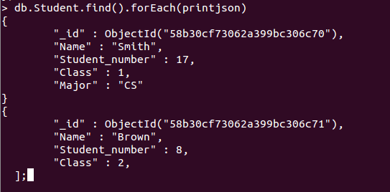

**2.To create a collection “Course” and to insert fields:**

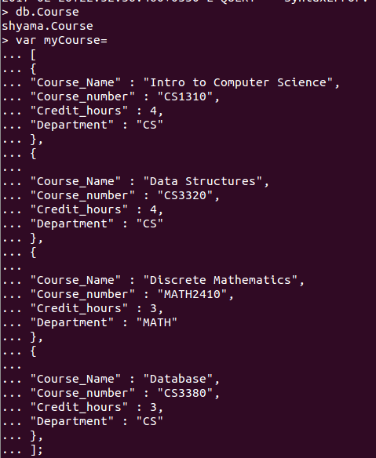

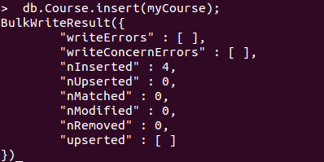

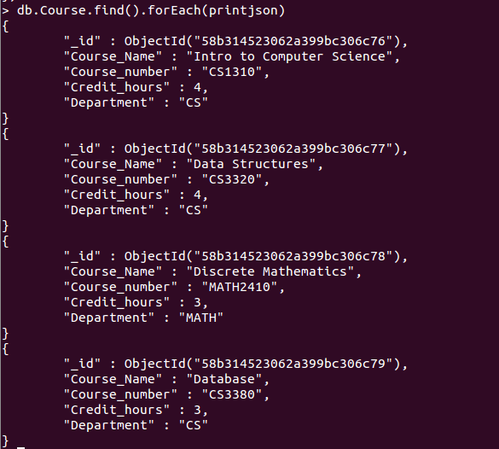

**3.To create collection “Section” and to insert fields:**



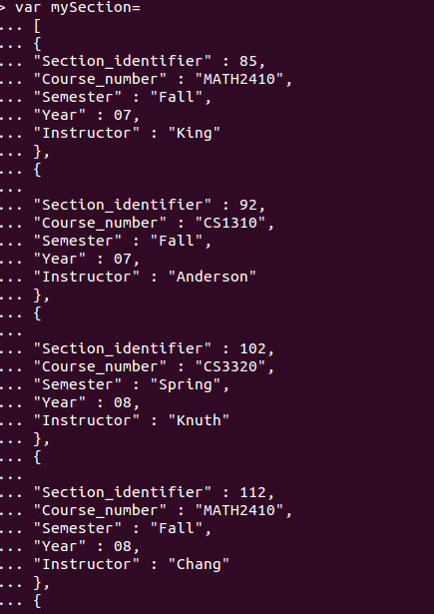

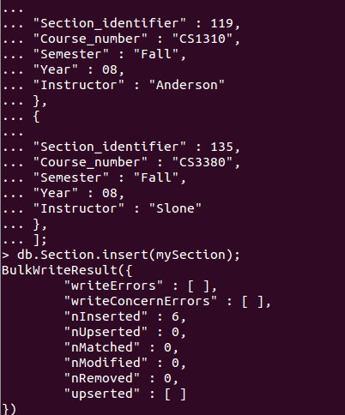

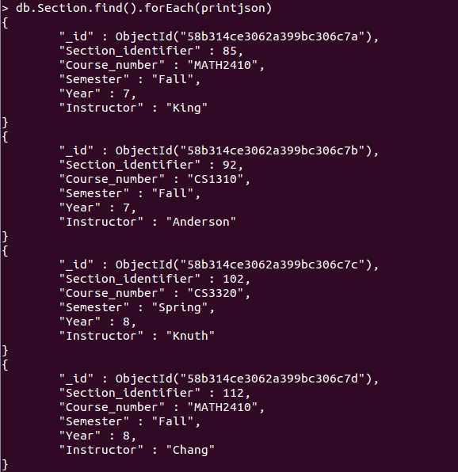

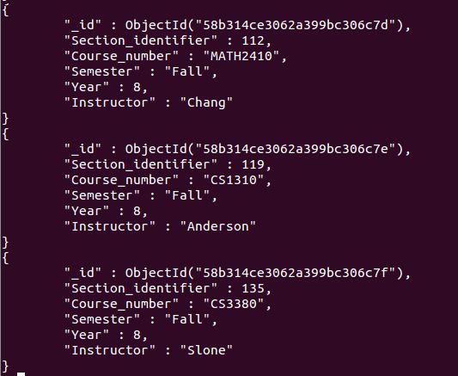

**4.To create collection “GradeReport “ and to insert the fields:**

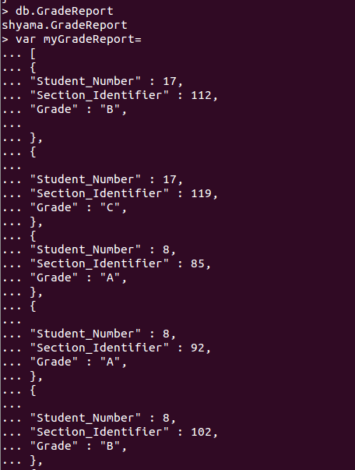

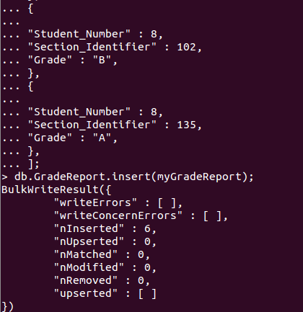

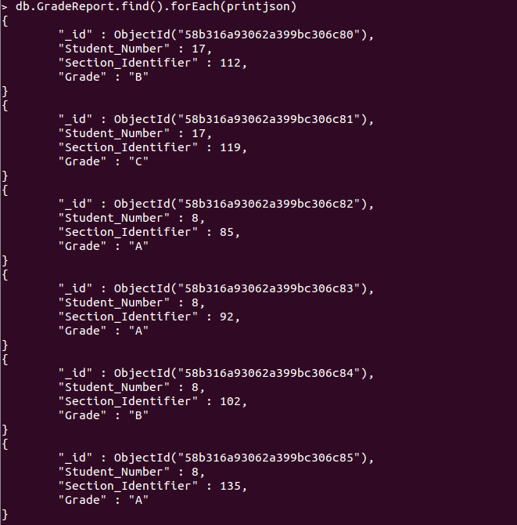

**5.To insert collection “Prerequisite” and to enter the fields:**



